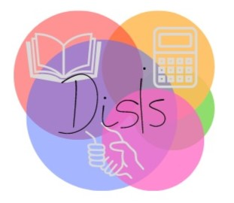

Arișanu Mihai

Barbu Timea

Bobei Alexandra

Oltean Luca

DisIs

2. OUR TARGET GROUP

1.PRODUCT - PROBLEM WE SOLVE

5. PROMOTION

4. PRICE

3. SMART OBJECTIVES

5.

**Hardcore** entrepreneur **hackathon** 3.0

IDEA IN SHORT: Our project consists in creating an application that guides parents and teachers and helps them understand whether or not a child has learning disorders and if so to guide them to a specialist in the field

PROJECT NAME: TEAM MEMBERS:

Our target is to make parents aware that their children can suffer from dyslexia and they must intervene in time. This problem also needs to be made aware at the national level because in our country dyslexia is not known as a problem and there are no programs that can help parents realize if their children suffer from it and help them further. Thus our team wants to make this idea known in Romania as well.

We are attempting to raise awareness of learning disabilities in Romania, where the term "dyslexia" solely refers to reading issues. The term "specific learning disorders" is used to describe a wide range of learning challenges, including dyslexia, including problems with reading, writing, calculus, and mathematical thinking.

We want to let you know that one in five persons have difficulties with learning and paying attention, and that no two dyslexic kids exhibit exactly the same symptoms or have exactly the same difficulties. So we created an application that will help the parents to find out if their children have dyslexia .Parents have a subjective opinion about their children, and in most cases, if kids present have symptoms, they refuse to believe that it is something wrong and have the impression that the little ones need more time to understand or manage to do certain things.

We thought of creating a blog where we will present our application and how it should be used. Here, parents will be able to ask us questions about the content and absolutely everything related to our application. We will present the payment method, useful information about dyslexia and here they will have a section where they can talk with the specialists

Users will have free access to information about specific learning disorders, but to receive advice from specialists in the field, you must log in, and there you will receive details about the subscription that users are willing to pay. Here there will be a standard monthly subscription that will include resources for parents of the type of specific learning disorders specified, for the support of specialized specialists we will negotiate for the most affordable price.

1. Solving social problems
2. Quick help through virtual methods
3. Reducing family expenses
4. Awareness of educational institutions in Romania
5. Ease of using this appilcation